1.3. Virtual Environments in Python

Creating the virtual environment:
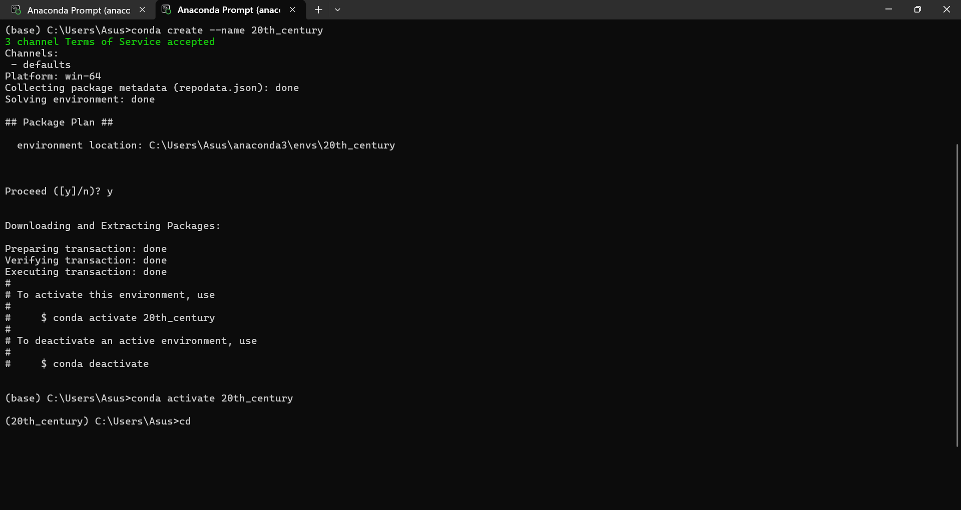
Notebook with the 20th_century kernel:
